# To preview the whole data in the dataset

SELECT ride_id, started_at, ended_at, ride_length, day_of_week, start_station_name, end_station_name, member_casual

FROM Cyclistic

ORDER BY ride_id DESC

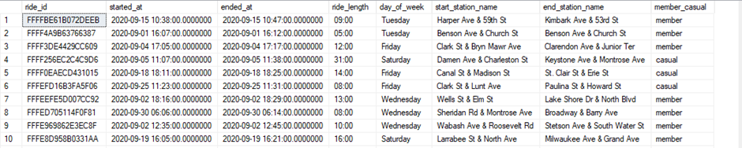

# Total Trips: Members vs Casual

# Looking at overall, annual member and casual rider totals

SELECT

TotalTrips,

TotalMemberTrips,

TotalCasualTrips,

ROUND(CAST(TotalMemberTrips AS FLOAT) / TotalTrips, 2) * 100 AS MemberPercentage,

ROUND(CAST(TotalCasualTrips AS FLOAT) / TotalTrips, 2) * 100 AS CasualPercentage

FROM

(

SELECT

COUNT(ride_id) AS TotalTrips,

COUNT(CASE WHEN member_casual = 'member' THEN 1 END) AS TotalMemberTrips,

COUNT(CASE WHEN member_casual = 'casual' THEN 1 END) AS TotalCasualTrips

FROM

Cyclistic

) AS subquery;



# Average Ride Length

SELECT

AVG(DATEPART(MINUTE, CONVERT(datetime, '00:' + ride_length)) * 60 +

DATEPART(SECOND, CONVERT(datetime, '00:' + ride_length))) / 60 AS AvgRideLength_Overall

FROM Cyclistic;

SELECT

AVG(DATEPART(MINUTE, CONVERT(datetime, '00:' + ride_length)) * 60 +

DATEPART(SECOND, CONVERT(datetime, '00:' + ride_length))) / 60 AS AvgRideLength_Member

FROM Cyclistic where member_casual = 'member'

SELECT

AVG(DATEPART(MINUTE, CONVERT(datetime, '00:' + ride_length)) * 60 +

DATEPART(SECOND, CONVERT(datetime, '00:' + ride_length))) / 60 AS AvgRideLength_Casual

FROM Cyclistic where member_casual = 'casual'

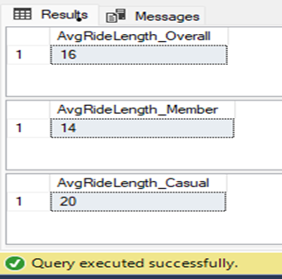

# Maximum Ride Length - Members vs Casual

-- Looking at max ride lengths to check for outliers

SELECT TOP 2

member_casual,

MAX(ride_length) AS ride_length_MAX

FROM

Cyclistic

GROUP BY

member_casual

ORDER BY

ride_length_MAX DESC;

# Maximum Ride Length - Members vs Casual

# Looking at max ride lengths to check for outliers

SELECT TOP 2

member_casual,

MAX(ride_length) AS ride_length_MAX

FROM

Cyclistic

GROUP BY

member_casual

ORDER BY

ride_length_MAX DESC;

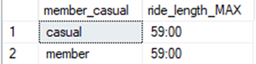

# Looking at top 100 longest trips for casual riders

SELECT TOP 100

member_casual,

ride_length

FROM

Cyclistic

WHERE

member_casual = 'casual'

ORDER BY

ride_length DESC;

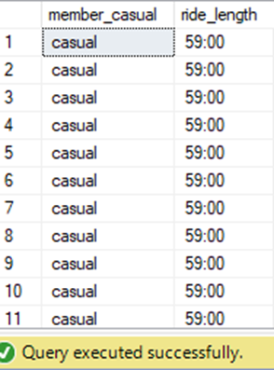

# Busiest day for rides

# Looking at which days have the highest number of rides

SELECT TOP 2 WITH TIES

member_casual,

day_of_week AS mode_day_of_week -- Top number of day_of_week

FROM

(

SELECT

DISTINCT member_casual, day_of_week, ROW_NUMBER() OVER (PARTITION BY member_casual ORDER BY COUNT(day_of_week) DESC) rn

FROM

Cyclistic

GROUP BY

member_casual, day_of_week

) subquery

WHERE

rn = 1

ORDER BY

member_casual DESC;

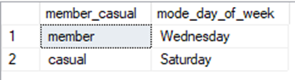

# Total Rides Per Day

# Looking at total number of trips per day

SELECT TOP 7

day_of_week,

COUNT(DISTINCT ride_id) AS TotalTrips,

SUM(CASE WHEN member_casual = 'member' THEN 1 ELSE 0 END) AS MemberTrips,

SUM(CASE WHEN member_casual = 'casual' THEN 1 ELSE 0 END) AS CasualTrips

FROM

Cyclistic

GROUP BY

day_of_week

ORDER BY

TotalTrips DESC;

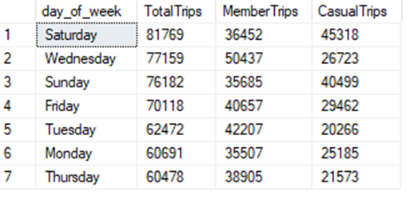

# Most popular start stations for trips

SELECT

DISTINCT start_station_name,

SUM(

CASE WHEN ride_id = ride_id AND start_station_name = start_station_name THEN 1 ELSE 0 END

) AS total,

SUM(

CASE WHEN member_casual = 'member' AND start_station_name = start_station_name THEN 1 ELSE 0 END

) AS member,

SUM(

CASE WHEN member_casual = 'casual' AND start_station_name = start_station_name THEN 1 ELSE 0 END

) AS casual

FROM

Cyclistic

GROUP BY

start_station_name

ORDER BY

total DESC, casual DESC, member DESC

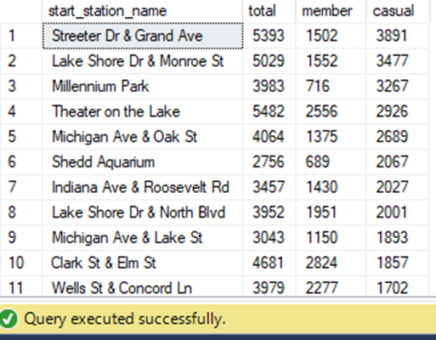

# Top start Station name for casual riders

SELECT

DISTINCT start_station_name,

SUM(

CASE WHEN ride_id = ride_id AND start_station_name = start_station_name THEN 1 ELSE 0 END

) AS total,

SUM(

CASE WHEN member_casual = 'member' AND start_station_name = start_station_name THEN 1 ELSE 0 END

) AS member,

SUM(

CASE WHEN member_casual = 'casual' AND start_station_name = start_station_name THEN 1 ELSE 0 END

) AS casual

FROM

Cyclistic

GROUP BY

start_station_name

ORDER BY

casual DESC

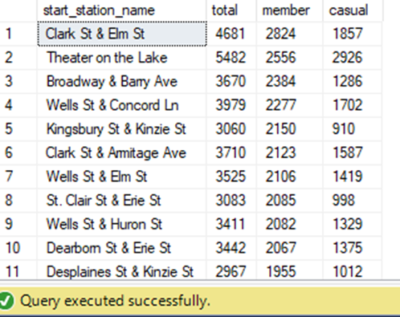

# Top Start Station Name for Members

SELECT

DISTINCT start_station_name,

SUM(

CASE WHEN ride_id = ride_id AND start_station_name = start_station_name THEN 1 ELSE 0 END

) AS total,

SUM(

CASE WHEN member_casual = 'member' AND start_station_name = start_station_name THEN 1 ELSE 0 END

) AS member,

SUM(

CASE WHEN member_casual = 'casual' AND start_station_name = start_station_name THEN 1 ELSE 0 END

) AS casual

FROM

Cyclistic

GROUP BY

start_station_name

ORDER BY

member DESC

# Popular End Station Name

SELECT

DISTINCT start_station_name,

SUM(

CASE WHEN ride_id = ride_id AND start_station_name = start_station_name THEN 1 ELSE 0 END

) AS total,

SUM(

CASE WHEN member_casual = 'member' AND start_station_name = start_station_name THEN 1 ELSE 0 END

) AS member,

SUM(

CASE WHEN member_casual = 'casual' AND start_station_name = start_station_name THEN 1 ELSE 0 END

) AS casual

FROM

Cyclistic

GROUP BY

start_station_name

ORDER BY

casual DESC

